

**Summary of Analysis:**

We conducted analysis of 15 schools and total 39,170 students and have prepared this report for your consideration. Total budget was $24,649,428.

Based on the available data it appears that average score and passing percentage was better in ‘Maths’ indicating there is an area of improvement with student’s ‘Reading’ abilities.

The percentage of students who passed both maths and reading are significantly lower indicating more resources need to be spent and measures need to be in place to improve overall performance.

Average maths score: 70.34

Average reading score: 69.98

The percentage of students with a passing maths score: 86.08%

The percentage of students with a passing reading score: 84.43%

The percentage of students who passed maths and reading: 72.81%

Based on the available data following conclusions can be drawn:

**Conclusion1:**

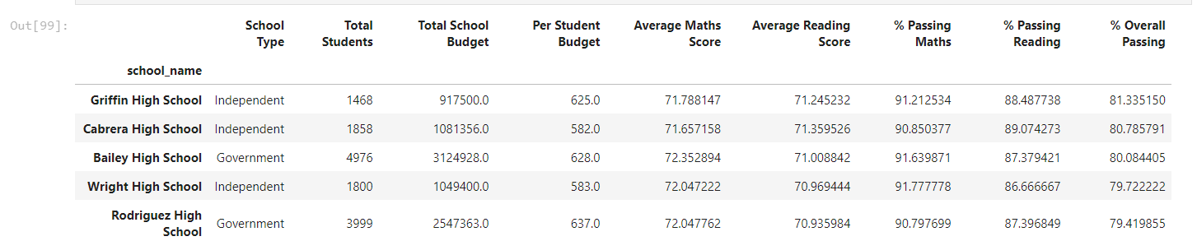

Based on the above chart top 5 schools are:

Griffin High School

Cabrera High School

Bailey High School

Wright High School

Rodriguez High School

**Conclusion2:**

Based on the above chart bottom 5 schools are:

Hernandez High School

Huang High School

Johnson High School

Wilson High School

Ford High School

**Conclusion3:**

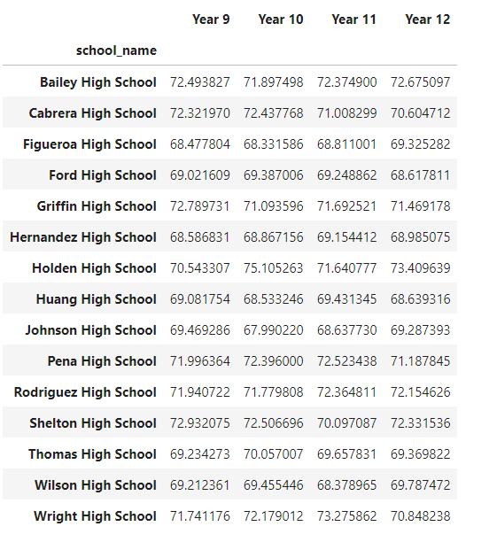

Even though Holden High School is not in the top 5 performing schools, Year10 students from the Holden High School had the top average maths score out of all as per the above chart.

**Conclusion4:**

Even though Holden High School is not in top 5 schools, Year 11 students from Holden High School had the highest average reading score out of all as per the above chart.

**Conclusion5:**

Spending more money per student has no significant impact on their ability to perform/pass exams or achieve better results. Instead from the above-mentioned chart it appears that students from schools that spent $585 - $630 per student are the highest performing across all categories. These students have achieved highest scores and passing percentage is better than others as well.

**Conclusion6:**

From the above mentioned chart it appears that the number of students makes impact on overall performance of the school i.e. lower the number of students the better overall performance of the school. Schools with less than 1000 students have excelled in all categories.

**Conclusion7:**

From the abovementioned chart it appears that the Independent schools have performed better than Government schools. Government schools need measures put in place to improve overall performance.